Ginkgo Biloba 40 mg |  | Pharmaceutical Manufactures India
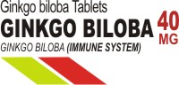 | 
Overview:
Ginkgo (Ginkgo biloba) is one of the oldest living tree species and its leaves are among the most extensively studied botanicals in use today. In Europe and the United States, ginkgo supplements are among the best-selling herbal medications. It consistently ranks as a top medicine prescribed in France and Germany.
Ginkgo has been used in traditional medicine to treat circulatory disorders and enhance memory. Scientific studies throughout the years have found evidence to support these uses. Although not all studies agree, ginkgo may be especially effective in treating dementia (including Alzheimer's disease) and intermittent claudication (poor circulation in the legs). It also shows promise for enhancing memory in older adults. Laboratory studies have shown that ginkgo improves blood circulation by dilating blood vessels and reducing the stickiness of blood platelets.
Ginkgo leaves contain two types of chemicals (flavonoids and terpenoids) believed to have potent antioxidant properties. Antioxidants are substances that scavenge free radicals -- compounds in the body that damage cell membranes, tamper with DNA, and even cause cell death. Free radicals occur naturally in the body and grow in number as we age. But environmental toxins (including ultraviolet light, radiation, cigarette smoking, and air pollution) can also increase the number of free radicals. Free radicals are believed to contribute to health problems including heart disease and cancer as well as Alzheimer's disease and other forms of dementia. Antioxidants such as those found in ginkgo can help neutralize free radicals and may reduce or even help prevent some of the damage they cause.
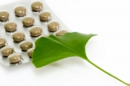
Plant Description:
Ginkgo biloba is the oldest living tree species. A single tree can live as long as 1,000 years and grow to a height of 120 feet. It has short branches with fan-shaped leaves and inedible fruits that produce a strong odor. The fruit contains an inner seed, and there has been a report of a human poisoning from ingesting the seed. Ginkgos are tough, hardy trees and are sometimes planted along urban streets in the United States.
Although Chinese herbal medicine has used both the ginkgo leaf and seed for thousands of years, modern research has focused on the standardized Ginkgo biloba extract (GBE), which is prepared from the dried green leaves. This standardized extract is highly concentrated and seems to be clinically more effective in treating health problems (particularly circulatory ailments) than the non-standardized leaf alone.
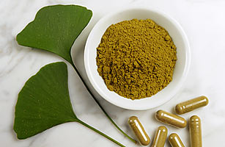
What Is It?
Ginkoba Memory contains the scientifically tested Ginkgo Biloba leaf extract which historically has been used in traditional Chinese medicine. Ginkoba Memory's clinically proven GB3® (Ginkgo Biloba Triple-Standardized) extract is concentrated 50:1 Ginkgo Biloba leaf standardized to 24% Ginkgo Flavone glycosides and 6% Terpenes to provide a consistent level of the active ingredients.
What's It Made Of ? :
More than 40 components isolated from the ginkgo tree have been identified, but only two are believed to be responsible for the herb's medicinal effects: flavonoids and terpenoids. Flavonoids are plant-based antioxidants. Laboratory and animal studies have shown that flavonoids protect the nerves, heart muscle, blood vessels, and retina from damage. Terpenoids (such as ginkgolides) improve blood flow by dilating blood vessels and reducing the stickiness of platelets.

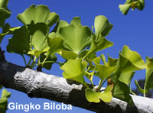
Medicinal Uses and Indications:
Based on studies conducted in laboratories, animals, and humans, gingko is used for the following:
Dementia and Alzheimer's disease
Ginkgo is widely used in Europe for treating dementia. It was used originally because it improves blood flow to the brain. Now further study suggests it may work directly to protect nerve cells that are damaged in Alzheimer's disease. A number of studies have found that gingko has a positive effect on memory and thinking in people with Alzheimer's or vascular dementia.
Clinical studies suggest that ginkgo may provide the following benefits for people with Alzheimer's disease:
Improvement in thinking, learning, and memory (cognitive function)
Improvement in activities of daily living
Improvement in social behavior
Fewer feelings of depression
Several studies have found that ginkgo may be as effective as prescription Alzheimer's medications in delaying the symptoms of dementia.
However, one of the longest and best-designed studies found ginkgo was no better than placebo in reducing Alzheimer's symptoms. In a 2008 study, 176 people in the United Kingdom with Alzheimer's took either ginkgo or placebo for 6 months. At the end of the study there was no difference in cognitive function or quality of life between the groups.
Ginkgo is sometimes suggested to prevent Alzheimer's and dementia, as well, and some studies have suggested it might be helpful. But in 2008, a well-designed study (the GEM study) with more than 3,000 elderly participants found the ginkgo was no better than placebo in preventing dementia or Alzheimer's.
Intermittent Claudication
Because ginkgo improves blood flow, it has been studied in people with intermittent claudication (pain caused by reduced blood flow to the legs). People with intermittent claudication have a hard time walking without feeling extreme pain. An analysis of eight published studies revealed that people taking ginkgo tend to walk roughly 34 meters farther than those taking placebo. In fact, ginkgo has been shown to be as effective as a prescription medication in improving pain-free walking distance. However, regular walking exercises are more beneficial than ginkgo in improving walking distance.
Glaucoma
One small study found that people with glaucoma who took 120 mg of ginkgo daily for 8 weeks had improvements in their vision.
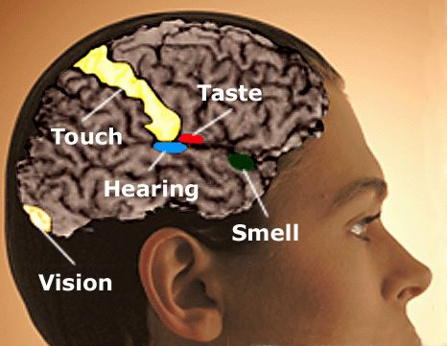
Memory Enhancement
Ginkgo is widely touted as a "brain herb." It has been studied to see whether it can improve memory in people with dementia, and some studies found it did help. It's less clear whether ginkgo helps improve memory in healthy people who experience normal memory loss that comes with age. Some studies have found slight benefits, while other studies have found no effect on memory. The most effective dose seems to be greater than or equal to 240 mg per day. Ginkgo is commonly added to nutrition bars, soft drinks, and fruit smoothies to boost memory and enhance cognitive performance, although it's doubtful that such small amounts of gingko would be effective.
Macular Degeneration
The flavonoids found in ginkgo may help stop or lessen some retinal problems (problems with the back part of the eye). Macular degeneration (often called age-related macular degeneration or ARMD) is an eye disease that affects the retina. It is a progressive, degenerative eye disease that tends to affect older adults and is the number one cause of blindness in the United States. Some studies suggest that gingko may help preserve vision in those with ARMD.
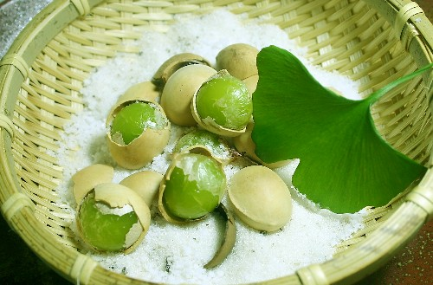

Tinnitus
Nerve damage and certain blood vessel disorders can lead to tinnitus (ringing, hissing, or other sound in the ears or head when no external sound is present). Because ginkgo improves circulation, it has been studied to see whether it can treat tinnitus. A few poorly designed studies found it might moderately relieve the loudness of the tinnitus sound. However, a well-designed study including 1,121 people with tinnitus found that ginkgo (taken 3 times daily for 3 months) was no more effective than placebo in relieving symptoms of tinnitus. In general, tinnitus is a very difficult problem to treat.
Other
A standardized ginkgo extract was reported to significantly improve functional measures (such as coordination, energy level, strength, mental performance, mood, and sensation) in 22 people with multiple sclerosis (MS).
How to Take It:
Pediatric
Ginkgo is not generally used in children.
Adult
Initial results often take 4 - 6 weeks, but should grow stronger beyond that period.
Memory impairment and cardiovascular function: Generally, 120 mg daily in divided doses, standardized to contain 24 - 32% flavone glycosides (flavonoids or heterosides) and 6 - 12% triterpene lactones (terpenoids). If more serious dementia or Alzheimer's disease is present, up to 240 mg daily, in 2 or 3 divided doses, may be necessary.
Intermittent claudication: 120 - 240 mg per day
Precautions:
If you are taking a prescription medicine, such as an anticoagulant agent (a blood thinner), are pregnant or are nursing, please contact your doctor before taking Ginkoba Memory. In case of accidental ingestion/ overdosage, seek the advice of a healthcare professional immediately. Keep this product out of the reach of children.


The use of herbs is a time-honored approach to strengthening the body and treating disease. Herbs, however, contain components that can trigger side effects and interact with other herbs, supplements, or medications. For these reasons, herbs should be taken with care, under the supervision of a health care provider qualified in the field of botanical medicine.
GBE is generally considered to be safe, and side effects are rare. In a few cases, gastrointestinal upset, headaches, skin reactions, and dizziness were reported.
There have been a number of reports of internal bleeding in people who take ginkgo. However, it is not clear whether ginkgo was responsible or whether there was another cause (whether a combination of ginkgo and blood-thinning drugs caused the bleeding, for example). One human study found that ginkgo significantly prolonged bleeding time when given along with cilostazol (Pletal), a commonly used blood-thinner. However, other studies found that gingko combined with warfarin (Coumadin) did not prolong bleeding time. Because of the uncertainty, you should ask your doctor before taking gingko if you also take blood-thinning drugs.
If you take gingko, you should stop taking it at least 36 hours prior to surgery or dental procedures due to the risk of bleeding complications. Tell your doctor or dentist that you take gingko.
People who have epilepsy should not take gingko, because there is concern that it might cause seizures.
Pregnant and breastfeeding women should not take gingko.
Do not eat Ginkgo biloba fruit or seed.
